**AFRICAN GPZ 5500 MOLECOLAR DETECTOR**

**FOR GOLD, SILVER, BRONZE, CAVITY**

CONTENTS

Pieces of detector 3

control buttons and explanations 4

A hand search system with laser scanner-15

Digital laser detector 5 years

Determination of the destination path 6

Targets at long distances 7

Objectives that include minerals 8

Large objects buried 8

Other explanations on 9

Objective detect line 9

Power line 9

Signal selection 9

Notification Sound on / off 9

Battery indicator 9

Search system with dual antenna 10

Determination of destination by means of "getting in the" 12

Determining the depth of a buried object 13

Determination of voids 14 goals

Determination of the depth of cavity 15

Specifications 16

16 Aftercare

Transporting the detector 17

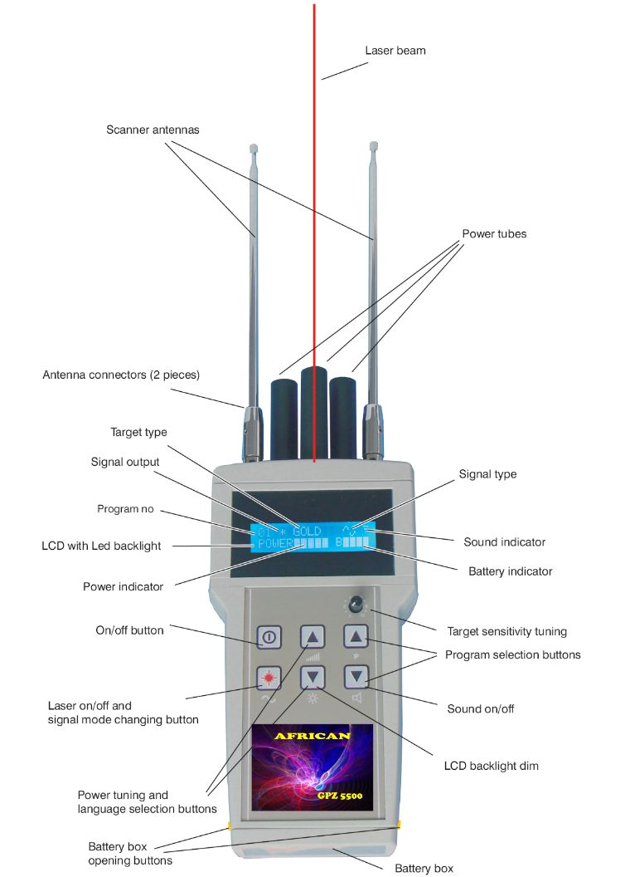

INTRODUCTION

Before the invention of the metal detector, the people have nothing more than simple metal rods to find reserves of gold and silver. Although these rods were not very reliable, Spanish in America, have been used to find many mines of precious metals.

Nowadays, with the development in electronics, detectors can find mines of precious metals and treasures from long distances can be made. Finding places precious metals from long range will not be difficult with a detector that is made with electronic circuits and highly developed technology, combined with the talent of a qualified and experienced. GPZ 5500 long-range detectors have been developed for the detection of gold, silver, bronze, cavity. In its electronic circuit, a brand new micro-processor American and many other integrated circuits, transistors, etc. are used.

From this, you can create the proper frequencies for gold, silver, bronze, cavity.

GOOD HUNTING!

A lot of time is needed to search large areas with regular coil detectors, because the whole area to be searched every inch due to the nature of these detectors, which have only a signal as they pass over the target. GPZ 5500 Detectors long haul, you will be able to search a large area in a very short time, which will decrease your time looking at a significant point.

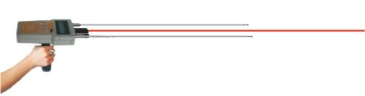

**INSTRUCTIONS FOR USE**

**1 - There should be no watches, mobile phones or any other electronic device for the operator during use and the detector should not be used less than 30 meters (100 feet) in this type of devices.**

Otherwise, there may be erroneous results.

2 - In every search for buried targets, other people around should not be in front of you. Otherwise, the detector can detect as gold, silver, etc. that may be on people. Objects that are far and above ground will have no effect.

DIGITAL LASER DETECTOR EXERCISES

It is not necessary to switch on the detector while doing these exercises.

For the detector to detect small targets, there are places bearings in the handle. The detector can turn around the handle about 270 degrees around freely. Search for a stable, the operator must know his / her hand with the position held. The operator must keep the detector in a stable manner and in a non-fatiguing. While walking the antennas should not move left or right. Operators using a detector such as this plane the first time must do exercises enough for a stable position of a company.

Keep the detector opening the antennas and holding at chest level as you can see on the photo. If the antennas point slightly downwards balance can be maintained more easily. If you turn from the waist, keeping your arm still and open your feet, you can make a search easier. If you tilt the left or right hand during the search, the balance will be lost and the detector will turn in that direction. It is possible to recognize this and immediately fix the position of a hand. Gaining experience you will be able to do the research in a better and more stable. Searches will be useful for erstand und if you are on a right path or less the same area. The detector detects more powerful in the zones in which are buried large objects, rather than the new ones. As is known, when an object remains below ground, the halo effect that more ago, and this makes it easier detected by the detectors. In new buried objects (even the object is old), it is possible for a strong alone. For a test, if you wait a couple of days after the burial in gold or silver, you will see that the detector can detect stronger.

When you are sure that you will easily do the research, it's time to exercise with the detector turned on. For this take-all and start exercising on targets buried.

TEST TEST TEST

First, the experience must be gained with the objectives of the first note. You can get this experience with the exercise in open spaces such as gardens, fields etc.

DIGITAL EXERCISE laser detector (continued)

1 - Connect Carefully handle the detector.

2 - Insert the battery in the detector. Open the battery cover by pressing both buttons to open the battery cover. Connect the battery clip to the battery by checking the + - poles. After inserting the battery carefully, close the ILD. The rechargeable battery is not fully charged, because of this charge the battery for 10-15 hours after the first use.

3 - Carefully connect the telescopic antennas, the long one in the middle and the two short sides. Make sure that the antennas are connected properly. Since there is a system block to antenna connectors, disconnect the antennas by pressing keys on the connectors blacks. Otherwise, the antennas can be damaged.

4 - For the exercises, bury one or more of gold, silver or bronze objects without wrapping anything around them. Why are new buried electrical conduction to the ground, pour a bit 'of water on them. If you exercise after 2-3 days, it will be seen that the force of attraction increases.

5 - Open the long antenna in the middle to the end. The antenna will bend slightly due to its own weight.

6 - Turn on the device, etc. after the brand, the language selection menu is displayed. Select the desired language using the arrow keys in the middle and to accept the selection, press the sound button. The detector will hold the selection in its memory and no new selection will be necessary in every use.

7 - Select the desired metal with the program buttons. The flashing star near the program indicates that the output signal is not active and you can begin your search.

8 - Set the sensitivity of the target button control to 0 (zero).

9 - You can check the battery, the battery indicator. The indicator decreases gradually, while the voltage decreases and at the lowest level, LCD backlight flashes and a beeper indicates. The battery must be replaced in this situation. For the Count battery

DETERMINATION OF THE POSITION TARGET

Switch on the detector and adjust the detector medium power. For initialization, wait for 2-3 minutes and touch the tip of the antenna to the ground for a short period. Turn your back to the north and turn to the area that you are going to search.

Search the area from left to right and from right to left. The antennas sit still when the lens is also continuing to turn the handle, the antennas to be pointing the target. Make this application tries a couple of times until you are sure of your target. A strong attraction can mean a big target at long distance or a small target within walking distance. Searches must be done in a southerly direction by at least 3 other points to determine the location of destination.

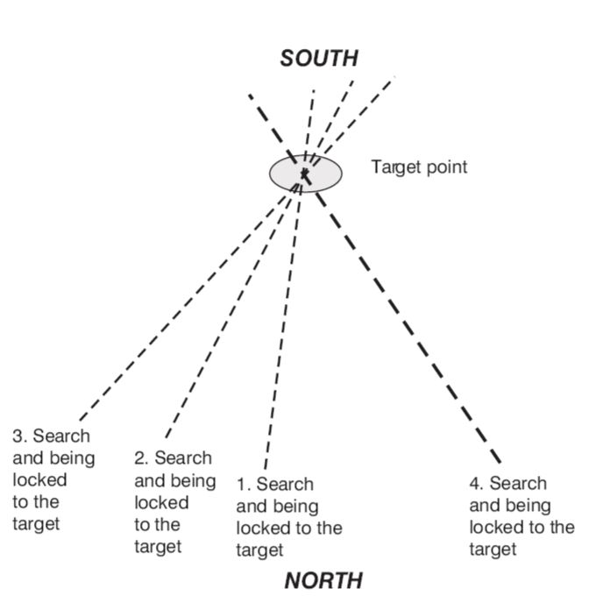

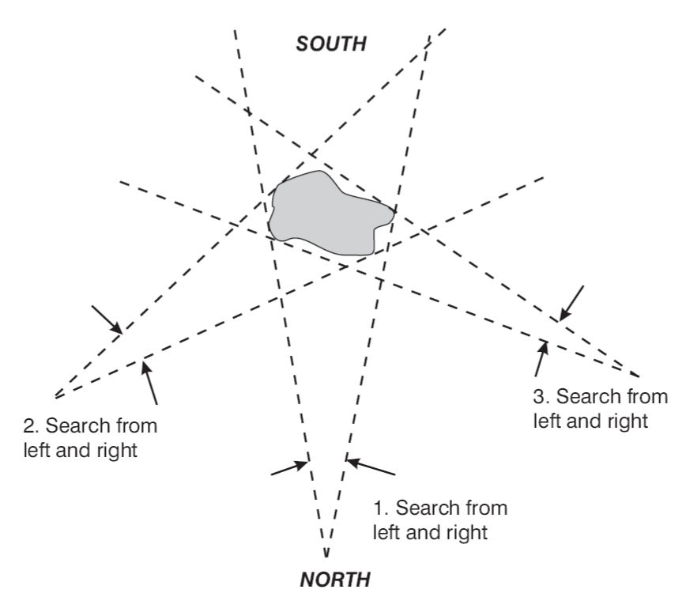

Let's say that the antennas are locked on the target during the search, in this situation, with the help of the laser beam, mark this direction, drawing a line on the floor or putting marks, or use natural landmarks such as trees, rocks, etc. Move left or right about 10-15 steps and try again toward the target. The antennas must be re-locked to the target. Also mark this direction and mark the points of intersection of the two lines. Move again 10-15 steps in the same direction and find another line which carries the target. Your goal should be about the intersection of these three lines. If there are more than one of the objects buried in the area, you can determine target positions closer research. With this method, a small area with scattered objects can be found. In this situation, you can use a normal metal detector to find the objects by one.

OBJECTIVES IN distances

To avoid errors that can be caused by the earth's magnetic field, research needs to be done from north to south. Determine the direction of the target in a large area with trees, rocks, etc. things stationary if the antennas are locked on a target. Determine the second and third when the antennas are blocked from changing your place. We say these lines intersect at a point very far, closer to the target and with the aid of the laser on the detector attempts to determine the target position more clearly. Using a normal metal detector to verify the double of the target highly reduce errors.

OBJECTIVES WHICH INCLUDES MINERALS

The following method can be used to discriminate desired targets from rocks with high amounts of minerals or areas.

If the target is determined extent, the operator approaches the target and still searches 3-4 different points. These searches are done from left to right and from right to left twice. If it is not a target point but a large mineral bed, when the detector is looking from left to right, reaches the left side of the bed and when the detector is looking from right to left, reaches the right side of the bed. When this operation is done by 3-4 places, the target frame is delineated. These components of the target block are not very stable on targets containing high mineral, which is why all research points to another direction.

LARGE OBJECTS BURIED

If the destination is not a target point, but a very big attraction will power up and the lines found by the research of the left and right will be in the same direction and much more stable. They will not change position in any search.

EXPLANATION OTHER USE

1-TARGET SENSITIVITY TUNING

After you start to use the detector in a more comfortable and stable, you can make this adjustment to be more attractive and more accurate determination of the target position. Why does this have a gold, silver or bronze with you. Bury the one you are going to look into the ground about 10 cm (4 inches). If the soil is dry, pour a little 'water on it. Turn on the detector point and gradually tuning sensitivity and target seeking 10 meters (30 feet) further in every degree, control the power and attraction if the detector shows the target or not. Exit at tuning where there is more attraction and reliability to the direction of the target. For better results and more accurate you need to make this adjustment in every place you go.



2-POWER TUNING

When searching in confined spaces, if do not want you to detect detector distances, it is necessary to reduce the power of your detector. To decrease rang and you can use the buttons. But you must take into account that the search depth is reduced a bit 'in this

3-SIGNAL SELECTION

There are two types of waves in the detector being sine and square waves. When you turn on the detector, which produces mostly sine waves and it works this way. A high mineral concentrated areas and bad condition, you can try with square-wave signals. To do this, press the button until the display on the screen and continue the search as described above.



4 - NOTIFICATION SOUND ON / OFF

The detector has a sound system of notification. When the buttons are pressed and the battery is low, is the subject of the notification sound. For silent operation press the button until the sound disappears figure on the display. To turn the sound on doing the same thing until the figure of the sound is again on display.



5-BATTERY INDICATOR

The detector has a rechargeable battery and a battery compartment for use regular batteries. You can continue the search if the rechargeable battery is exhausted and replaced by AA batteries (alkaline). You can check the status of the battery at any time from the display detectors. As the battery voltage December reased the battery indicator decreases gradually and when you need to replace the battery, the battery can last begin to disappear.

SEARCH SYSTEM WITH ANTENNAS DOUBLE -2

USE OF SATELLITE RECEIVER

Before you start looking, you need to learn to keep both antennas of the receiver in his hand. In doing these exercises, do not activate the detector, set it aside. First you have to exercise to walk with balanced receiver antennas in hand. As you can see in the photo, the antennas should be held about 30 cm (12 inches) away and chest parallel to the floor and each other.

You can bend the little antennas to the floor for a better balance. While walking not rotate the antenna left or right, and not make them bounce, why should remain in balance at all times. You can exercise for hours to be comfortable with this style of use. Will not be able to receive electronic signal of the object correctly unless Leam this good technique

Exercise until you have a good control on the antennae and as long as you maintain a stable and balanced with the antennas. You can do exercise can close in a closed place like your home or outside.

During training, you will experience the antennas that cross over and then return to its normal position. Do not worry in this case, this is very normal first tests. In the case of the body being sensitive additional antennas can move due to the magnetic fields of the Earth. The most important thing is to continue to exercise until you learn to take the antennas balanced and stable

It 's very likely that starters can feel awkward. You will see that when you start to be a bit 'of wind, you will start to lose control, but after a couple of hours of exercise you will see that you will be able to use the antennas correctly and easily.

When you are sure to use the antennas correctly and easily. When you are sure to use the antennas properly, it is time for you to start working with the detector.

For this, carefully remove the handle of the detector. Apply the ground electrode in the ground where they will try about 10 cm (4 inches) Connect the detector

Soil on the electrode as in the figure.



DETERMINATION WITH TARGET FOR THE METHOD IN BOX

This method allows the operator to determine the position of the target buried more precise. The operator a square around the target area that was previously found about 60 cm (2 feet) from the center. While this has been done, the antenna close to the target must be kept about 5 cm (2 inches) below the antenna.

When the foot operators is the same direction with the target, the external antenna rotates toward the target. Control 4 sides take more accurate location of the target.



DETERMINATION OF MOVING TARGET while digging

In some problem areas, there may be errors on the destination points which have been determined with the detector.

For example, we have found an object 3 meters (10 feet) deep. While digging, each half a meter (24 inches), the target location must be checked by the method of boxing, if there is no lens shift, the excavation will be done in less time and accurately.

In areas like this, double check the destination path with regular coil detectors will prevent unnecessary excavation.

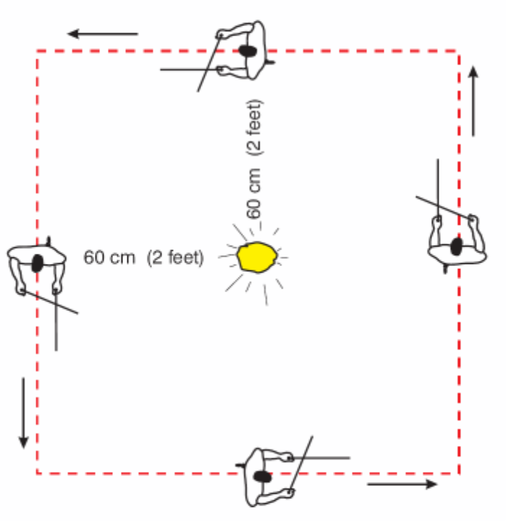

DETERMINATION OF DEPTH 'buried object

Here we show the results and the application of an application indicating the depth of an object that is about 3 meters (10 feet) deep.

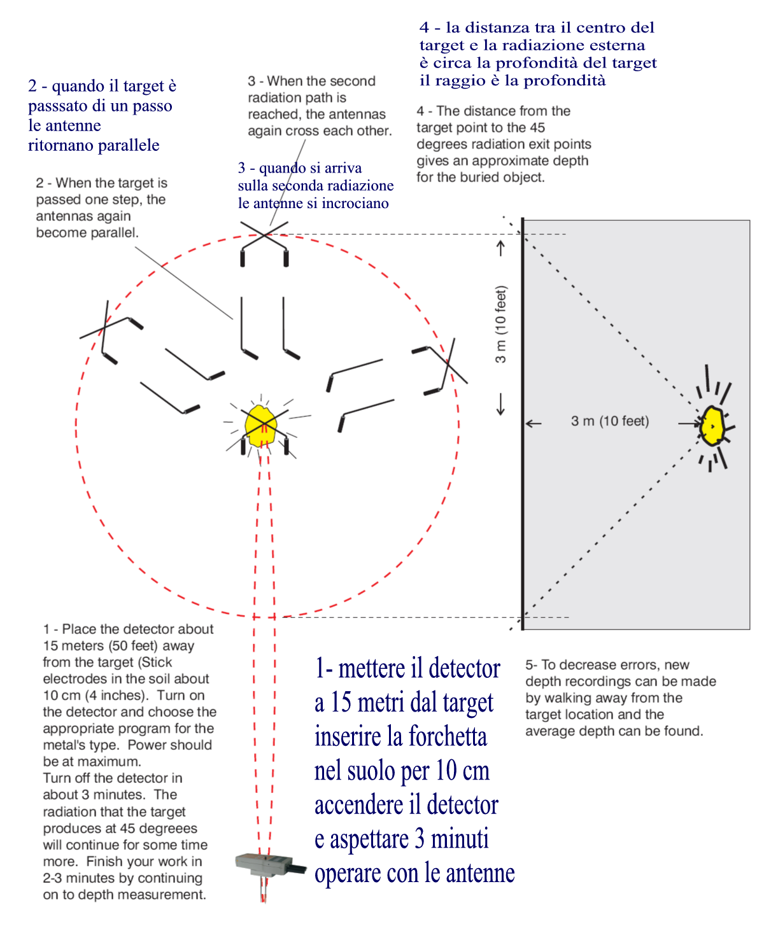

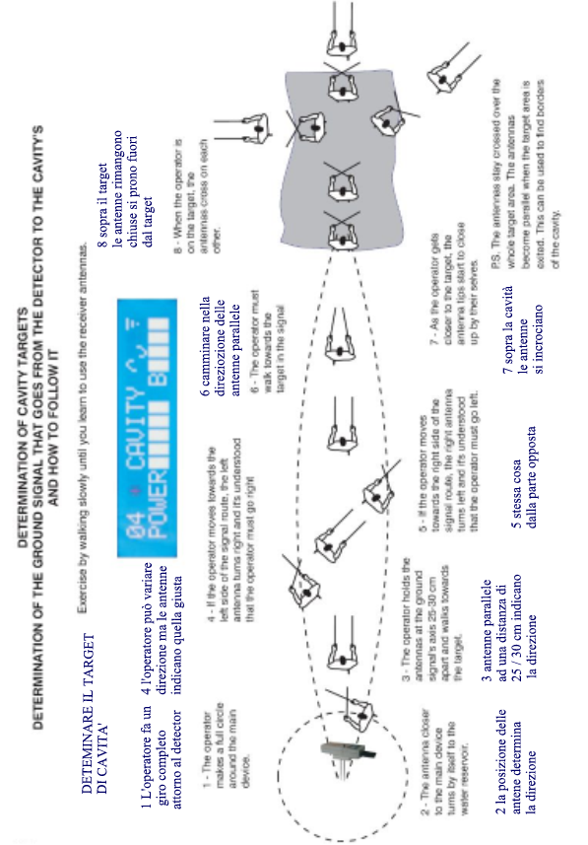

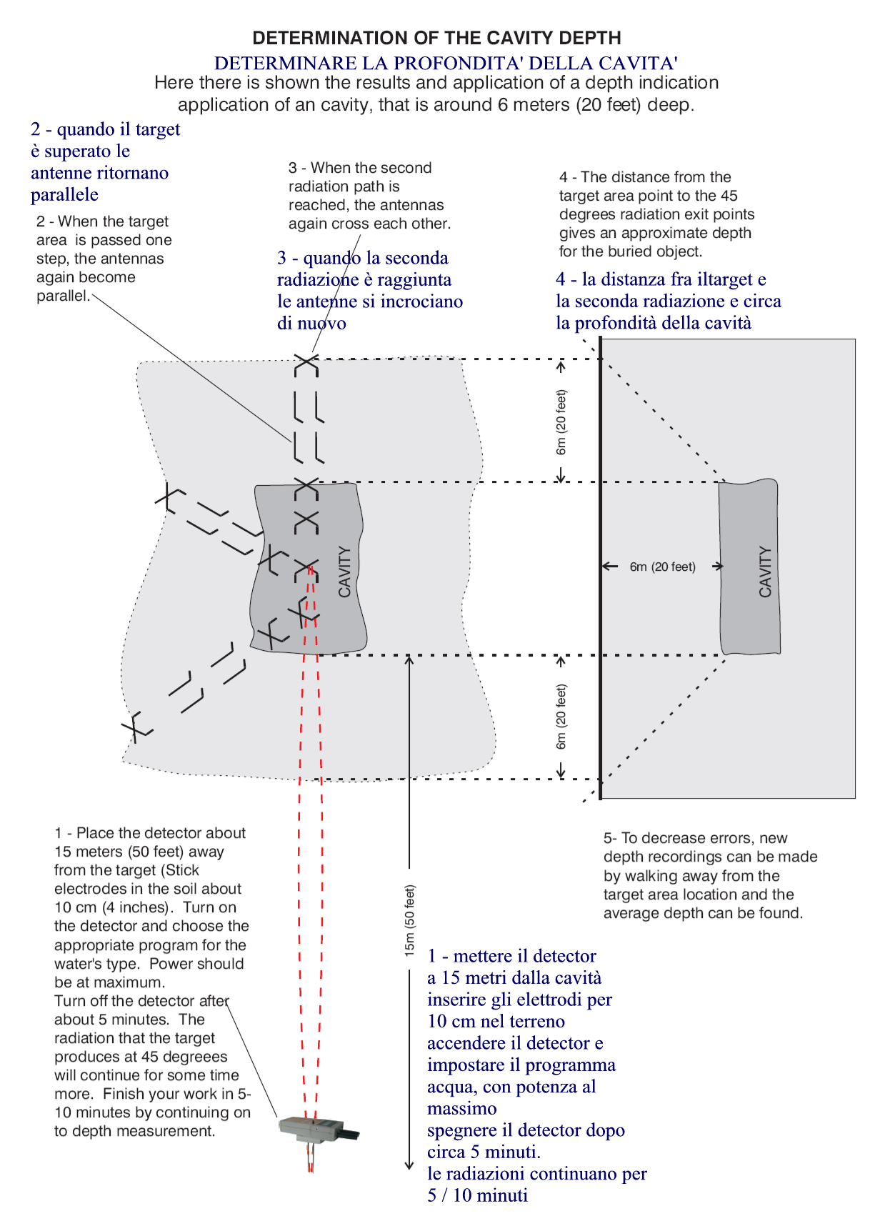

DETERMINATION OF depth of the cavity

Here is illustrated the results and the application of an application indication depth of a cavity, which is approximately 6 meters (20 feet) deep.

THE EFFECTS OF WEATHER CONDITIONS AND FIELD

It will always be useful to bring the golden and silver to control the sensitivity of the unit in case of bad weather. Explosions on the sun can have negative effects on this detector as on any other electronic devices in the world. This temporary situation in terms of time can take a couple of minutes, hours or more. Gloves can be worn in cold weather. In these situations, the best bet will be to wait until the conditions to heal. The change in the passage of the antennas in 30 seconds while on a buried object shows that the target is not real. This incident occurs mostly in areas with radioactive rocks.

For efficient use, not only the quality of the detector is important, but also the use is very important. A user is not educated and impatienc and can lead to problems when using the detector. For professional use, and practice must be made at least a couple of days, until it is sufficient for correct detection.

SPECIFICATIONS

Display: Graphic LCD (2x16)

Display backlight: LED blue

Microprocessor: American, 24 M Hz

Control buttons: touch operated

Laser scanner antennas telescopic, 2 pieces

Receiver antennas: special alloy, chrome plates, 1 pair

Probe the ground connections to hubs special alloy, chrome plated.

Neck: Connection hub special removable bearing sensitive, coated special rubber.

Operating voltage: 9.6V-12V

Battery: AA battery 8x1.5C.

Rechargeable battery: 9.6 V, 2200 mAh

Rated current: 140 mA

Laser: 2x5 mW, 5V

Charge Adapter: 11.2 Volts, 220 mA, with LED charge indicator (When the position is made full-LED dims)

Hardcase: ABS, sponge coating

Weight: 2.9 kg (Hardcase included)

Laser scanner Weight: 750 grams (battery included)

Aftercare

1 - The device is manufactured for harsh environments. However, we must not forget that the detector is a sensitive electronic device. Not be aware to use all the functions of your detector, but use it with care and protection.

2 - You need to protect the detector from extreme hot and cold. For example, do not leave it out in the sun on hot summer days or in the trunk of your car for a long time. Also, do not leave out in the cold winter days.

3 - Do not let the rain and in places with high humidity.

4 - The detector must always be clean. Clean the detector after each use. Do not use too wet a cloth etc. for this.

5 - If you do not intend to use the detector for a month or more, remove the battery from the battery box, do not leave the device.

Transport detector

The detector is an electronic device and the next must be paid attention to its transport.

1 - Place the detachable parts in Hardcase detectors or your package during transport. Do not carry the pieces randomly into a bag or container, etc. Where can harm each other or break.

2 - Be careful not to hit the transport everywhere, while the detector or drop on the floor.

3 - While the detector is in it's hardcase or package, do not leave it in rain, snow or under Dom

4 - Especially if it is carried by a land vehicle, must not be left under the sun, also on board the vehicle.

5 - When sending goods, so it is better for the parties to be in their original packaging, or you can not, packaged properly.